Log Based Failure Prediction Using Machine Learning(with agentic AI Extension)

Vuppalamurthy Nikhila Priya - 235816122 , N. Nirvika - 235816106
School of Computer Science and Engineering (SOCE), Manipal Institute of Technology, Bengaluru (MITB)

Abstract -
Keywords-

I. INTRODUCTION

Background
Modern software systems generate large volumes of log data that record systems events such as operations, warnings and error. Traditionally failure detection relies on manual analysis or rule-based methods ,which are inefficient and difficult to scale for complex systems .
System logs exhibit sequential patterns that can reveal underlying patterns associated with system behaviour. With advancement in machine learning, especially sequence models like Long Short-term Memory(LSTM) networks , it is possible to automatically learn these patterns and detect anomalies more effectively .
Leveraging these techniques, log-based analysis has emerged as an effective approach for predicting system failure in advance, thereby supporting proactive maintenance and improving overall system reliability.

Problem Statement
Despite the availability of large scale system log data, accurately predicting system failures remains a significant challenge due to the complexity and sequential nature of log patterns. Existing approaches often fail to effectively capture temporal dependencies in log sequences and struggle with highly imbalanced data , where failure instances are rare[1].
Further many existing solutions lack generalisation and are prone to issues such as data leakage ,leading to unreliable performance in real world scenarios [2]. In addition, limited attention has been given to model interpretability ,making it difficult to understand the underlying causes of predicted failures [3].
Therefore, there is a need to develop a robust ,scalable and interpretable machine learning-based approach that can effectively learn from log sequences , handle dat imbalance, and reliably predict system failures in advance.

Proposed Solution

D. Objectives
The primary objectives of this work is to develop an effective log-based failure prediction system using machine learning techniques. The specific objectives are as follows:
- To preprocess and transform raw system log data into structured sequential representations suitable for machine learning models[1]
- To design and implement a deep learning-based sequence model, specially Long Short-Term Memory(LSTM), to capture temporal dependencies in log data[2].
- To address the issue of class imbalance in log datasets in order to improve the detection of rare anomaly events [3].
- To ensure robust and unbiased model evaluation by avoiding data leakage and applying appropriate data splitting techniques [4].
- To enhance prediction performance through threshold optimization and the use of evaluation metrics such as precision , recall, and F1-score[5].
- To incorporate an explainability mechanism to interpret model predictions and identify key events contributing to system failures[6].

II. LITERATURE REVIEW
Log-based failure detection has been widely studied as an effective approach for improving system reliability in large scale distributed environments. Early work by Wei Xu et al.[2] introduced techniques for mining console logs to detect system anomalies, demonstrating that log data contains valuable information for identifying system issues. However, these approaches relied heavily on manual feature engineering and rule-based methods ,limiting their scalability and adaptability.
With the advancements of deep learning ,researchers began leveraging sequence modelling techniques for log analysis.Min Du et al.[1] proposed DeepLog,which uses Long Short-Term Memory (LSTM) networks to model normal log sequences and detect anomalies based on deviations. This approach significantly improved the ability to capture temporal dependencies in log data compared to traditional methods.
Despite these improvements ,challenges such as class imbalance remain critical in log-based failure prediction. Studies by Haibo He and Edwardo A. Garcia [7] highlight that imbalanced datasets can bias models toward majority classes ,reducing the effectiveness of anomaly systems.
Another major issue in machine learning-based systems is data leakage, which can lead to overly optimistic performance estimates .Shachar Kaufman et al.[4] emphasizes the importance of proper data splitting and validation techniques to ensure reliable evaluation .
Furthermore ,recent research has focused on improving the interpretability of machine learning models. Zachary C.Lipton[6] discusses the need for explainable models that provide insights into predictions ,which is particularly important in critical systems such as failure detection,
Building upon these works this project integrates sequence modelling, imbalance handling ,leakage prevention and explainability to develop a comprehensive log-based failure predicted system.

III. DATASET DESCRIPTION
The dataset used in this study is the HDFS(Hadoop Distributed File System ) log dataset, which is widely used for log-based anomaly detection and failure prediction tasks . It contains system generated log messages collected from a distributed computing environment.
The dataset consists of two main components : event traces and anomaly labels. The event trace file records sequences of log events associated with each system block ,identified by a unique Blockld. Each sequence represents the order of events occurring during the execution of a specific block . The anomaly label file provides corresponding labels for each Blockld, indicating whether the sequence is normal or anomalous.
Each log sequence is represented as a series of event identifiers capturing the temporal behaviour of the system. These sequences are later transformed into numerical form for machine learning processing.
The dataset exhibits class imbalance as the number of normal instances significantly exceeds the number of anomalous instances. This characteristics makes it suitable for evaluating the effectiveness of machine learning models in detecting rare failure events .
Overall ,the HDFS log dataset provides a realistic and structured representation of system behaviour ,making it an appropriate choice for developing and evaluating log-based failure prediction models.

IV. METHODOLOGY

A. System Architecture / Pipeline
• The overall architecture of the proposed system is designed to process raw log data and predict system failures using a deep learning model. The pipeline begins with log data collection, followed by preprocessing and sequence generation. The processed data is then fed into an LSTM-based model for learning temporal patterns. Finally, the model outputs the probability of failure, which is further refined using threshold optimization and interpreted using an explainability module.This architecture enables end-to-end processing of log data, ensuring accurate and scalable failure prediction in distributed systems [1].

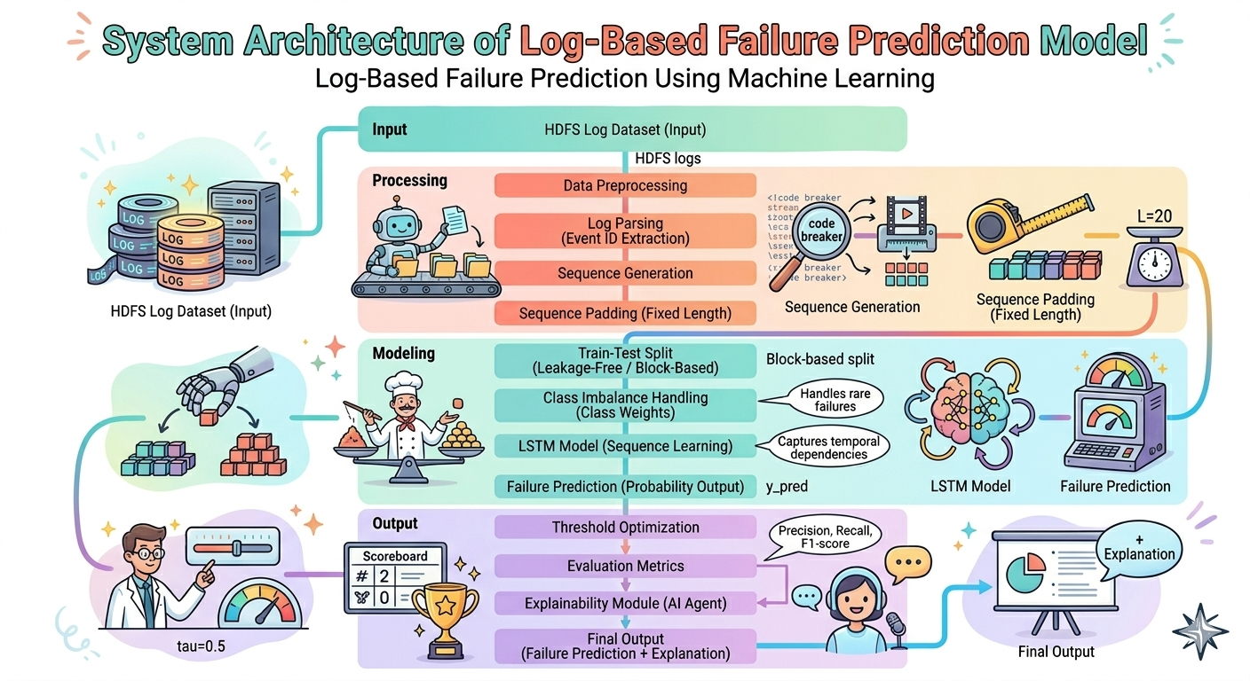
Fig. 1. End-to-end system architecture of the log based failure prediction pipeline, illustrating the data flow from ingestion through
preprocessing, model training, and evaluation.

Data Preprocessing
- Raw log data is inherently unstructured and requires transformation before being used in machine learning models. The event traces and anomaly labels are merged using a common identifier (BlockId). Log sequences are then parsed to extract event IDs and converted into numerical representations.
- To handle varying sequence lengths, padding is applied to ensure uniform input size. Additionally, class imbalance is addressed by computing class weights, allowing the model to effectively learn from minority (anomalous) instances [2].

C. Exploratory Data Analysis (EDA)

D. Evaluation Metrics

V. MODELS USED

A

.

B.

C.

VI. RESULTS AND ANALYSIS

A.

B.
.

C

VII. COMPARATIVE PERFORMANCE ANALYSIS

.

VIII.FINAL MODEL SELECTION

IX. DISCUSSION

X. FUTURE WORK

REFERENCES
- M. Du, F. Li, G. Zheng, and V. Srikumar, “Deep Log: Anomaly Detection and Diagnosis from System Logs through Deep Learning,” in Proc. ACM CCS, 2017.
- W. Xu et al., “Detecting Large-Scale System Problems by Mining Console Logs,” in Proc. ACM SOSP, 2009.
- J. Zhang et al., “Robust Log-Based Anomaly Detection on Unstable Log Data,” in Proc. ACM SIGSOFT, 2019.
- S. Kaufman et al., “Leakage in Data Mining: Formulation, Detection, and Avoidance,” ACM Trans. Knowledge Discovery from Data, 2012.
- T. Fawcett, “An Introduction to ROC Analysis,” Pattern Recognition Letters, 2006.
- Z. C. Lipton, “The Mythos of Model Interpretability,” ACM Queue, 2018.
- ] H. He and E. A. Garcia, “Learning from Imbalanced Data,” IEEE Trans. Knowledge and Data Engineering, 2009.

